# 

AWS Version 1.0

Sever Decommission Process



|  |  |  |  |  |  |
| --- | --- | --- | --- | --- | --- |
| Version No. | Created By | Reviewed By | Authorized By | Release Date | Modifications Done |
| 1.0 | Aakash Desai | SrinivasRao Pilli |  | 2/09/2021 | Initial Draft |

Table of Contents

|  |  |  |  |  |  |
| --- | --- | --- | --- | --- | --- |
| Version Number | Date | Comments | | | Approver |
| 1 | 02- Sept-2021 | Created by Aakash Desai | | |  |
|  | | |  |
|  |  |  | | |  |
|  |  |  | | |  |
|  |  |  | | |  |

1. **Introduction**

This procedure provides guidance and assistance to add a server to a Maintenance window.

1. **Objective**

To provide standard set of steps to add a server to a Maintenance window.

1. **Pre-requisites before Activities to be performed:**
2. Basic knowledge of AWS.
3. AWS console access.
4. Service Now access.
5. Maintenance window
6. **Pre-requisites/ Procedure**

Example.

|  |  |  |  |  |
| --- | --- | --- | --- | --- |
| AWS account | Region | Instance id | Server name | Maintenance window |
| HVAC_Com_Prod - 913828333602 | eu-west-1 | i-0f763a539ec02dbfa | CFRRYA3D | mw-051a016b51ece0c6f |

SearchHVAC_Com_Prod(Account name or 913828333602(Account id) in Search bar

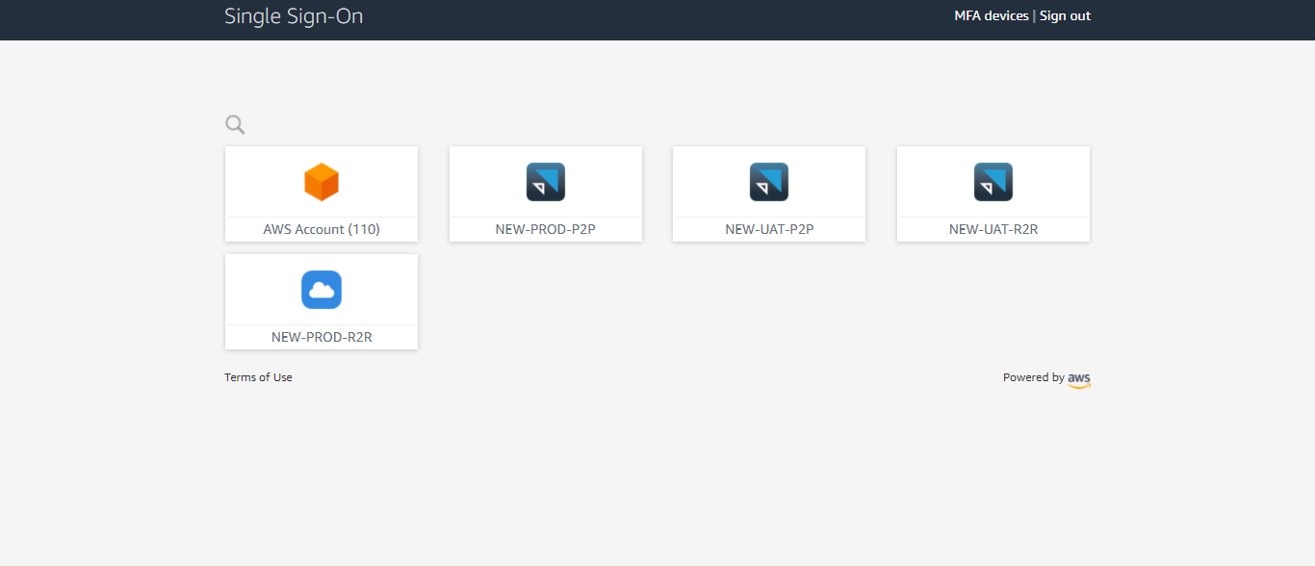

Check the region if it is eu-west-1 and then go to Systems Manager

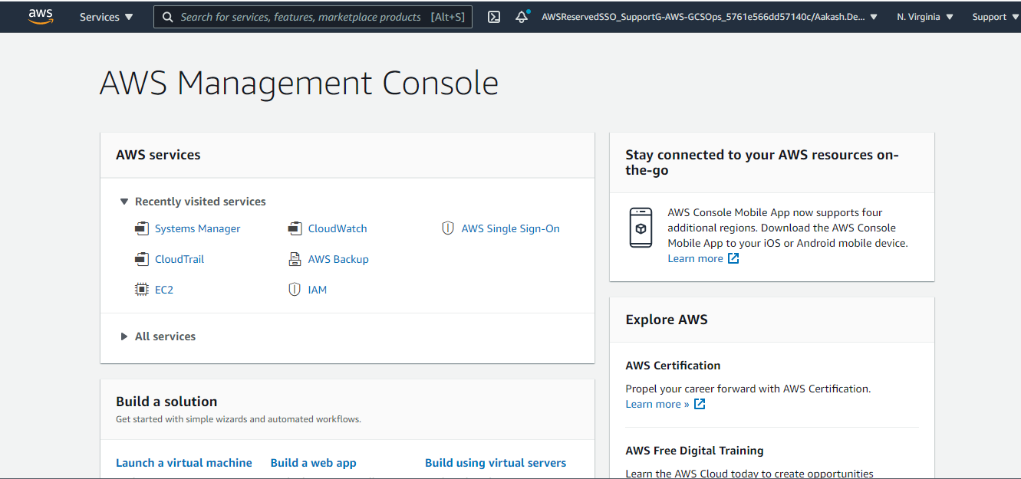

Scroll down in the left pane and Go to Maintenance window

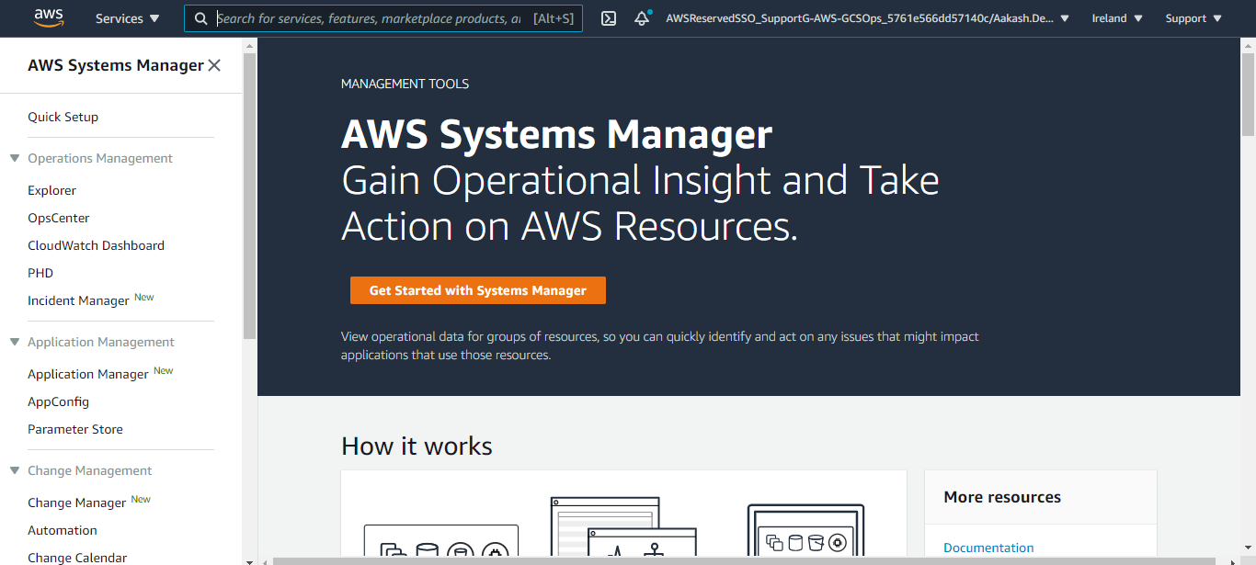

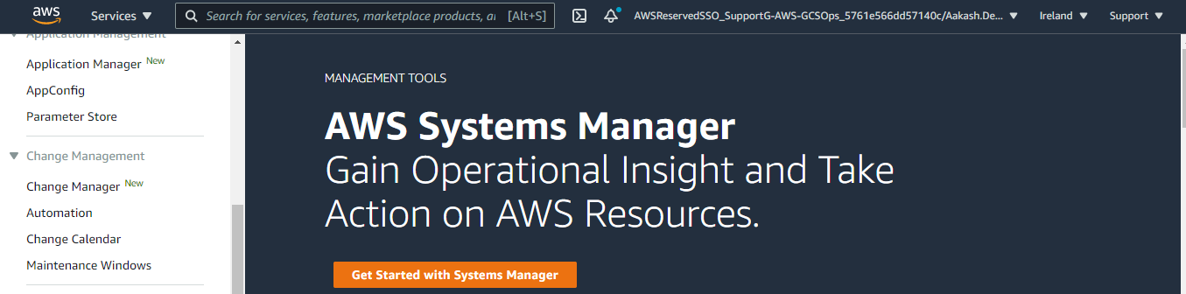

Select the maintenance window in which the server needs to be added.

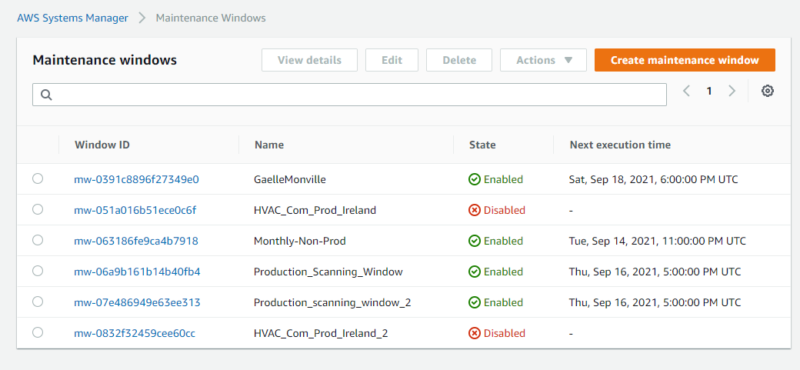

After selecting the Maintenance window go to Targets

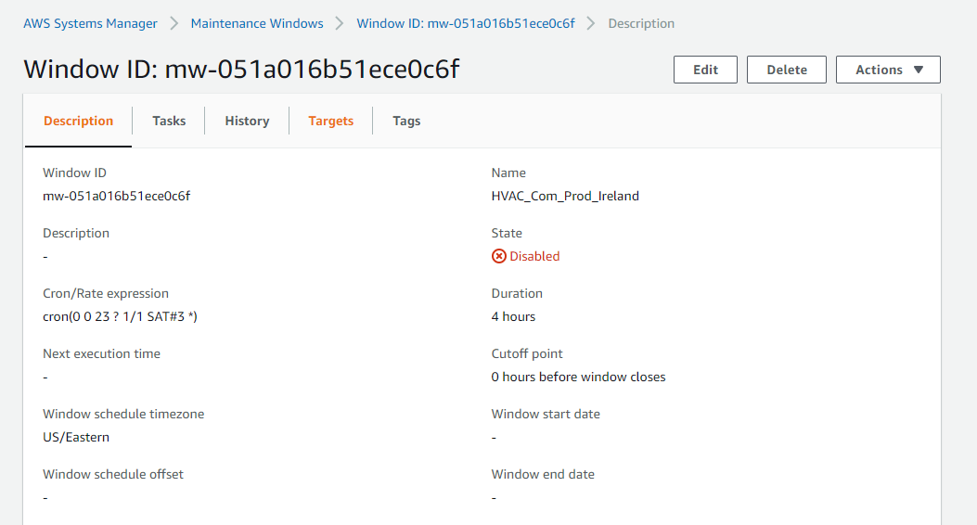

Select the radio button of Windows target ID and then click on Edit.

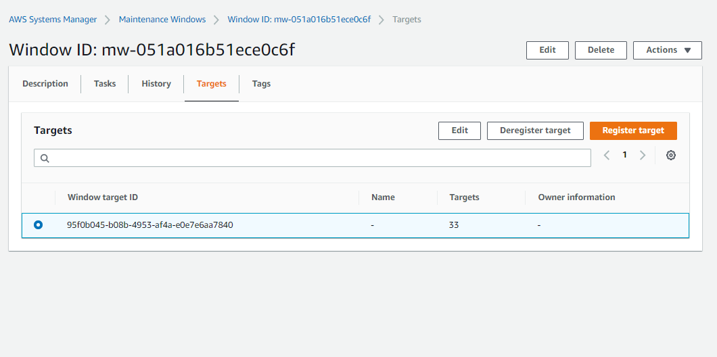

Scroll down in Edit targets

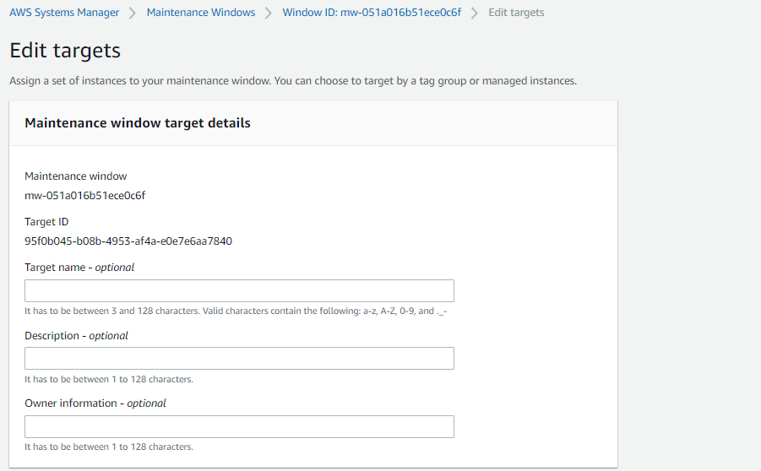

Go to Targets -> Select choose instances manually -> Search with Instance id of the server in Instances tab -> Select the server and click on Register target.

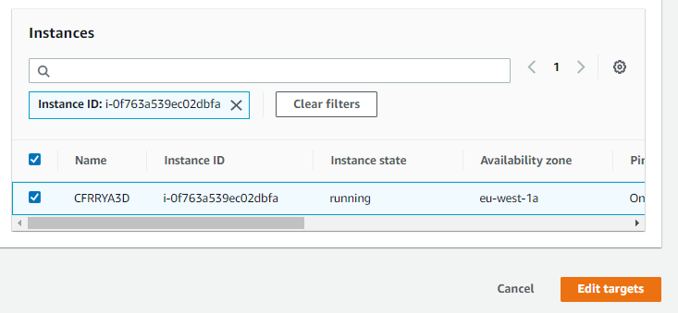

NOTE : If the server is in stopped state, do not include the server in maintenance window as complete maintenance windows gets failed if a server is in stopped state.